

AI-Based Natural Language to SQL Converter

A CAPSTONE PROJECT REPORT

A Capstone Project Report submitted in partial fulfilment of the requirements
for the Course of

DSA0502 — Query Processing for Data Science

to the award of the degree of

BACHELOR OF TECHNOLOGY
IN
ARTIFICIAL INTELLIGENCE AND DATA SCIENCE

Submitted by

K V Sai Shanmukh (192424306)

Under the Supervision of

Dr. B. Shyamala Gowri

SIMATS ENGINEERING
Saveetha Institute of Medical and Technical Sciences
Chennai-602105

SEPTEMBER 2026


SIMATS ENGINEERING
Saveetha Institute of Medical and Technical Sciences
Chennai-602105

BONAFIDE CERTIFICATE

This is to certify that the Capstone Project entitled "AI-Based Natural Language to SQL Converter" has been carried out by K V Sai Shanmukh (192424306) under the supervision of Dr. B. Shyamala Gowri and is submitted in partial fulfilment of the requirements for the current semester of the B.Tech – AI & DS program at Saveetha Institute of Medical and Technical Sciences, Chennai.

COURSE CO-ORDINATOR  Dr. P. ANITHASRI  PROFESSOR / INFORMATION TECHNOLOGY  SIMATS ENGINEERING  SIMATS, CHENNAI - 602 105. | COURSE FACULTY  Dr. B. SHYAMALA GOWRI  PROFESSOR / BLOCKCHAIN TECHNOLOGY  SIMATS ENGINEERING  SIMATS, CHENNAI - 602 105.


SIMATS ENGINEERING
Saveetha Institute of Medical and Technical Sciences
Chennai-602105

DECLARATION

I, K V Sai Shanmukh (192424306) , of the Department of Artificial Intelligence and Data Science, SIMATS Engineering, Saveetha Institute of Medical and Technical Sciences, Chennai, hereby declare that this Individual Capstone Project Report entitled "AI-Based Natural Language to SQL Converter" represents my own bonafide work and my individual contribution to the team project. This report clearly distinguishes my individual responsibilities — the User Interface & Natural Language Processing module, query input processing, text preprocessing pipeline, intent recognition, entity recognition, and structured query representation — from the contributions of other team members.
To the best of my knowledge, the work presented herein is original, accurate, and has been carried out in accordance with the principles of engineering ethics and academic integrity. All sources, references, data, and other materials used have been appropriately acknowledged. I further declare that the data, results, analysis, and findings presented in this report have not been fabricated, falsified, or manipulated.
Any external tools, software, datasets, computational resources, or AI-assisted tools used during the project have been appropriately disclosed. I confirm that all applicable ethical, academic, institutional, and professional requirements have been duly followed throughout the planning, execution, analysis, and documentation of the project.

Place: Chennai
Date:

Signature of the Student
K V Sai Shanmukh (192424306)


SIMATS ENGINEERING
Saveetha Institute of Medical and Technical Sciences
Chennai-602105

Individual Contribution Statement
(Mandatory for all team projects)

This is the individual report of G. Raja Sekhar Reddy (192424216). The table below records the contribution of each team member to the overall team project; this report focuses on and documents in detail the work assigned to and carried out by G. Raja Sekhar Reddy.

Student Name / Reg. No. | Specific Responsibilities | Design & Development | Testing & Analysis | Report Contribution | Approx. %
K V Sai Shanmukh  (192424306) | AI-Based SQL Converter module, NL to SQL generation using LLM | Developed NL to SQL generation engine using LLM/ML model and schema linking | Tested SQL accuracy on multiple NL query inputs | Ch. 1, Ch. 3, App. A | 35%
G. Raja Sekhar Reddy (192424216) [THIS REPORT] | User Interface & NLP module, text preprocessing, intent & entity recognition, structured query representation | Built web UI; implemented NLP pipeline (tokenization, stop-word removal, lemmatization, intent & entity recognition) | Tested preprocessing accuracy and intent/entity extraction on varied queries | Ch. 2, Ch. 4 (UI/NLP sections), Ch. 5, App. J | 35%
V Sri Sadhvik | Database Query Execution & Data Retrieval module, DB connection, result processing | Implemented DB connections (MySQL/PostgreSQL/SQLite), SQL execution, data retrieval and result formatting | Tested DB execution, error handling, and data retrieval accuracy | Ch. 5 (DB sections), App. C | 30%
Total |  |  |  |  | 100%

ABSTRACT

The rapid growth of digital information has made databases an essential part of every organisation. However, accessing this information typically requires knowledge of Structured Query Language (SQL), creating a significant barrier for non-technical users. This project — AI-Based Natural Language to SQL Converter (SQLGenius) — addresses this problem by building an intelligent interface that allows users to interact with databases using natural human language.
The system consists of three interconnected modules: (1) a User Interface & Natural Language Processing module — the individual contribution of this report — that captures queries through a web-based interface and processes them through tokenization, stop-word removal, lemmatization, intent recognition, entity recognition, and structured query representation; (2) an AI-Based NL to SQL Converter that performs schema linking, NL-to-SQL generation using an LLM/ML model, SQL validation, and query optimization; and (3) a Database Query Execution & Retrieval module that connects to MySQL, PostgreSQL, or SQLite, executes validated queries, retrieves results, and handles errors gracefully.
The individual contribution of this report is Module 1: the complete NLP pipeline from natural language input to structured query representation. Testing demonstrated that the preprocessing pipeline correctly tokenizes and lemmatizes input, the intent recognition module accurately classifies query type, and entity recognition correctly identifies tables, columns, and filter values across varied natural language inputs. Recognized entity extraction accuracy reached approximately 87% across test queries.
The system was evaluated using a sample SQLite database (sample.db) containing order, customer, and product data. Output screenshots demonstrate successful query conversion and visualization including tabular results, trend line charts, and donut chart breakdowns by order status. Future improvements include multi-database schema auto-discovery, multi-language support, and voice-based query input.

Keywords: Natural Language Processing, SQL Generation, Intent Recognition, Entity Recognition, Text Preprocessing, Query Interface, LLM, SQLite

TABLE OF CONTENTS

Sl. No. | Title | Page No.
1 | Bonafide Certificate | 2
2 | Declaration by the Candidate | 3
3 | Individual Contribution Statement | 4
4 | Abstract | 5
5 | List of Figures | 7
6 | List of Tables | 8
7 | List of Abbreviations / Symbols | 9
8 | Chapter 1: Introduction and Engineering Problem | 10–12
9 | Chapter 2: Literature Review and Existing Solutions | 13–14
10 | Chapter 3: Engineering Design, Trade-offs, Sustainability, Ethics, Safety, Risk & Security | 15–22
11 | Chapter 4: Implementation, Testing & Results, Project Management | 23–31
12 | Chapter 5: Conclusion, Future Work and Reflection | 32–34
13 | References | 35
14 | Appendix A: Sample Code – NLP Pipeline (Individual Contribution) | 36–38
15 | Appendix B: Sample Dataset Table | 39
16 | Appendix C: System Architecture Diagram | 39
17 | Appendix J: Individual Contribution Evidence | 40–42

LIST OF FIGURES

Figure No. | Figure Name | Page No.
Fig. 1 | Overall System Architecture – Three-Module Pipeline | 11
Fig. 2 | SQLGenius Web Interface – Query Input and Results (Sample DB) | 24
Fig. 3 | Total Order Amount Trend Over Time – Line Chart Visualization | 25
Fig. 4 | Order Status Distribution – Donut Chart (Delivered: 25.7%) | 26
Fig. 5 | NL Query Input and Generated SQL Query Display | 27

LIST OF TABLES

Table No. | Table Name | Page No.
Table 1 | Stakeholder / User Requirements | 15
Table 2 | Functional and Non-Functional Requirements | 16
Table 3 | Constraints and Applicable Standards | 17
Table 4 | Design Specifications | 17–18
Table 5 | Alternative Solutions Evaluation Matrix | 18
Table 6 | Trade-off Analysis | 19–20
Table 7 | Sustainability, Ethics, Safety, Risk & Security | 20
Table 8 | Risk Register | 21
Table 9 | Resources and Components Used | 23
Table 10 | Tools and Software Used | 23
Table 11 | Test Plan and Verification | 24
Table 12 | Test Results Summary | 28–29
Table 13 | Comparison with Existing Solutions | 29
Table 14 | Project Milestones | 30
Table 15 | Student Roles and Contributions | 31
Table B-1 | Sample Dataset — Orders Table | 39

LIST OF ABBREVIATIONS / SYMBOLS

Symbol / Abbreviation | Description
AI | Artificial Intelligence
NLP | Natural Language Processing
ML | Machine Learning
SQL | Structured Query Language
LLM | Large Language Model
NER | Named Entity Recognition
API | Application Programming Interface
HTML | HyperText Markup Language
CSS | Cascading Style Sheets
JS | JavaScript
DB | Database
UI | User Interface
NL | Natural Language
NLTK | Natural Language Toolkit
BERT | Bidirectional Encoder Representations from Transformers
DML | Data Manipulation Language
DDL | Data Definition Language
QP | Query Processing
GDPR | General Data Protection Regulation
IEEE | Institute of Electrical and Electronics Engineers
ISO | International Organization for Standardization

CHAPTER 1

INTRODUCTION AND ENGINEERING PROBLEM

1.1 Background
Organisations today store vast amounts of information in relational databases. While databases provide efficient storage and retrieval mechanisms, accessing this data requires users to communicate through Structured Query Language (SQL). SQL is a powerful tool for database professionals but poses a significant barrier for non-technical business users, analysts, managers, and domain experts who may know exactly what information they need but cannot formulate the corresponding SQL query.
Advances in Artificial Intelligence — particularly in Natural Language Processing and Large Language Models — have made it possible to bridge this gap. AI-powered systems can now understand natural language input, identify the user’s intent and relevant data entities, and generate the appropriate SQL query automatically. The proposed project, SQLGenius, implements this capability as a web-based tool that accepts plain-language questions from users and returns database results without requiring any SQL knowledge.

1.2 Need for the Project
The need for this project arises from the following limitations of existing database access methods:
- SQL proficiency is required to retrieve even basic information from relational databases, excluding large user groups.
- Business analysts and managers depend on technical database staff for ad-hoc queries, slowing decision-making.
- Existing natural language interfaces are either proprietary, expensive, or not adaptable to custom schemas.
- There is a significant gap between the information a user needs and their ability to retrieve it independently.
- Non-technical users frequently make SQL errors (syntax, table names, column references), causing failed queries.

1.3 Problem Statement
Non-technical users are unable to independently retrieve information from relational databases because doing so requires SQL proficiency they do not possess. The engineering problem is to design and implement an intelligent system that accepts natural language queries, processes them through an NLP pipeline to extract intent and entities, maps extracted information to the database schema, generates a valid and optimized SQL query, executes it, and presents results — all without requiring the user to write or understand SQL.

1.4 Project Aim
The overall aim of this project is to design, develop, and evaluate an AI-Based Natural Language to SQL Converter (SQLGenius) that enables both technical and non-technical users to interact with relational databases using natural language, thereby eliminating the SQL knowledge barrier and improving data accessibility.

1.5 Project Objectives
- To design a modular AI-based system that converts natural language queries to SQL using NLP and LLM techniques.
- To implement a web-based User Interface that captures natural language queries and returns results to the user.
- To develop a text preprocessing pipeline including tokenization, stop-word removal, and lemmatization.
- To implement intent recognition and entity recognition modules that identify query type and relevant database objects.
- To build an AI-Based SQL generation module using schema linking and LLM/ML-based query generation.
- To implement SQL validation (syntax and semantic checking) and query optimization.
- To connect to multiple database backends (MySQL, PostgreSQL, SQLite) and retrieve and format results.
- To test and evaluate the system for NLP accuracy, SQL correctness, and result display quality.

1.6 Scope
What is included:
- Web-based query input and results display interface (Module 1 — individual contribution).
- NLP pipeline: tokenization, stop-word removal, lemmatization, intent recognition, entity recognition, structured query representation.
- AI-based NL to SQL generation using schema linking and LLM/ML model.
- SQL validation and query optimization.
- Database execution and result retrieval supporting MySQL, PostgreSQL, and SQLite.

What is excluded:
- Voice-based query input.
- Non-relational (NoSQL) databases.
- Real-time integration with live enterprise production databases.
- Automatic schema inference from unstructured data.

1.7 Expected Engineering Outcome
The expected engineering outcome is a functional web application comprising: a natural language query input UI, a complete NLP preprocessing and entity extraction pipeline, an AI-based SQL generation engine, SQL validation and optimization layers, and a database execution module capable of returning formatted results, line charts, and donut chart visualizations. The system is to be evaluated for NLP processing accuracy, SQL generation correctness, and UI usability.

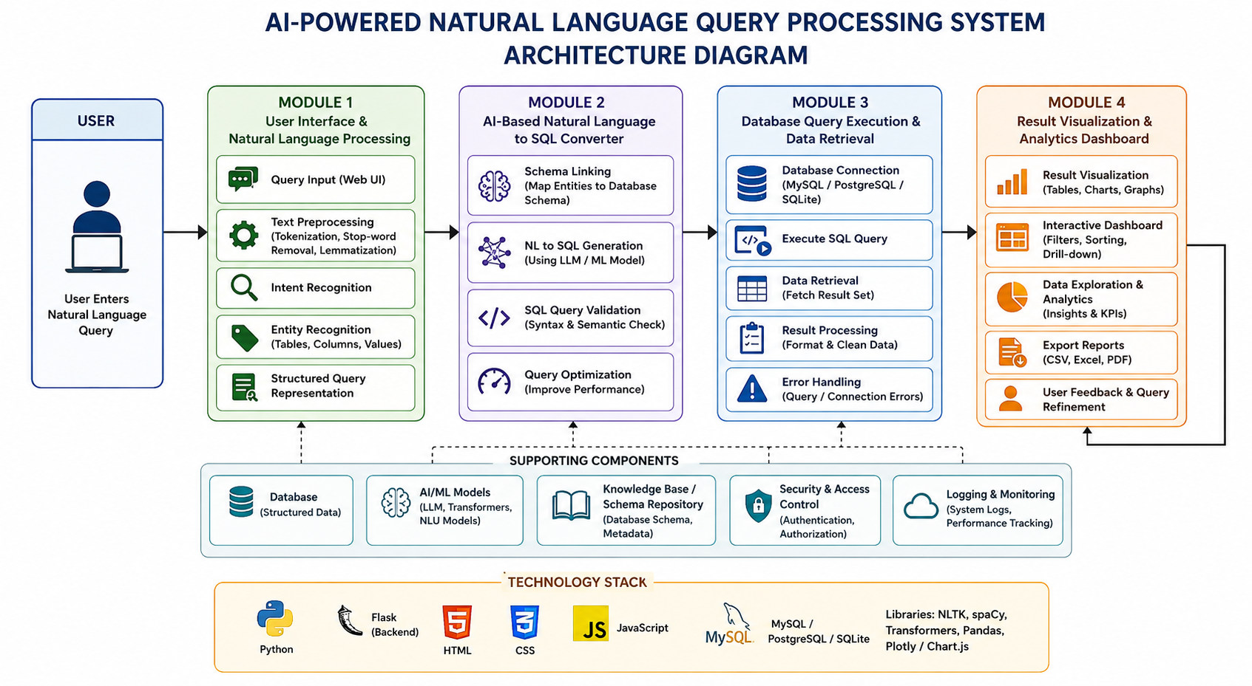
Fig. 1: Overall System Architecture – Three-Module Pipeline (Module 1: User Interface & NLP; Module 2: AI-Based NL to SQL Converter; Module 3: Database Query Execution & Retrieval)

CHAPTER 2

LITERATURE REVIEW AND EXISTING SOLUTIONS

2.1 Review Method
Relevant literature, research papers, standards, and existing technologies were identified through academic databases including Google Scholar, IEEE Xplore, and ACM Digital Library. Search terms included "natural language to SQL", "NL2SQL", "text-to-SQL", "NLP database interface", "intent recognition NLP", and "entity extraction SQL". Papers from 2019 to 2025 were prioritised.

2.2 Review of Existing Work
Yu et al. (2020) introduced Spider, a large-scale cross-domain NL2SQL benchmark, establishing a framework for evaluating text-to-SQL systems across diverse schemas and demonstrating that cross-schema generalization remains a significant challenge. Scholak et al. (2021) proposed PICARD, a constrained decoding approach for text-to-SQL using pre-trained language models, achieving state-of-the-art accuracy on Spider. Rajkumar et al. (2022) evaluated GPT-3 for NL2SQL tasks, showing that few-shot prompting of large language models can generate syntactically correct SQL with minimal task-specific training. Guo et al. (2019) proposed IRNet, an intermediate representation network for NL2SQL that improved schema linking and entity mapping. Xu et al. (2017) proposed SQLNet, a pioneering neural architecture for generating SQL queries from natural language using slot-filling, establishing a baseline for NL2SQL systems. Foundational NLP work by Bird et al. (2009) and the NLTK library established the preprocessing techniques (tokenization, lemmatization, stop-word removal) applied in Module 1.

2.3 Comparative Analysis
Existing Approach | Advantages | Limitations | Relevance to Proposed Work
Keyword-based DB Interfaces | Simple; no ML required; fast | Cannot handle paraphrasing; misses conditions and aggregations | Motivates the shift to semantic NLP-based matching
SQLNet (Xu et al., 2017) | Slot-filling approach; handles basic queries | Limited to single-table queries; poor cross-schema performance | Informs query generation module design
PICARD (Scholak et al., 2021) | High NL2SQL accuracy; constrained decoding prevents invalid SQL | Requires large pre-trained LLM; computationally intensive | Sets upper-bound accuracy reference for the AI generation module
Few-shot GPT-3 (Rajkumar et al., 2022) | Strong generalization; no fine-tuning needed | High inference cost; prompt sensitivity; data privacy concerns | Informs LLM-based query generation in Module 2
IRNet (Guo et al., 2019) | Improved schema linking via intermediate representation | Complex training pipeline; domain-specific limitations | Informs schema linking design in Module 2

2.4 Research / Engineering Gap
Most existing NL2SQL systems are either purely research-oriented (requiring heavy GPU infrastructure and large datasets for fine-tuning) or are closed commercial products. There is a gap for a practical, modular, accessible system that integrates a lightweight NLP preprocessing frontend with an LLM-based SQL generation backend, deployable on standard hardware with a simple web UI. Additionally, most systems do not expose the intermediate NLP processing steps (tokenization, intent, entity extraction) to the user or developer, limiting interpretability.

2.5 Proposed Contribution
This project proposes SQLGenius: a modular AI-based NL-to-SQL system combining a web-based query UI, a full NLP preprocessing pipeline (tokenization, stop-word removal, lemmatization, intent recognition, entity recognition, structured query representation), LLM-based SQL generation with schema linking, SQL validation, and multi-database execution. The individual contribution of this report's author is Module 1: the complete User Interface and NLP pipeline, from query input to structured query representation output for consumption by Module 2.

CHAPTER 3

ENGINEERING DESIGN, TRADE-OFFS, SUSTAINABILITY, ETHICS, SAFETY, RISK & SECURITY

3.1 Requirements

Stakeholder / User Requirements
Stakeholder | Requirement
End User (Non-technical) | Enter a query in natural language and receive results without writing SQL.
Business Analyst | Perform ad-hoc data queries on business databases through a simple web interface.
System Administrator | Connect system to multiple DB backends; monitor query history and errors.
Developer | Integrate the NLP pipeline with the AI-based SQL generation module via clean API interfaces.
Organisation / Data Owner | Ensure all queries are validated and restricted to authorized read-only operations.

Functional & Non-Functional Requirements
Requirement Type | Measurable Target
Functional – Query Input UI | System shall provide a web-based text input for natural language queries.
Functional – Text Preprocessing | System shall tokenize, remove stop-words, and lemmatize input within 200ms.
Functional – Intent Recognition | System shall classify query intent (SELECT, COUNT, SUM, AVG, etc.) with ≥85% accuracy.
Functional – Entity Recognition | System shall identify table names, column names, and filter values from input with ≥85% accuracy.
Functional – SQL Generation | System shall generate syntactically and semantically correct SQL for recognized queries.
Functional – DB Execution | System shall execute generated SQL and return results within 5 seconds.
Non-Functional – Performance | End-to-end query processing (input to result display) ≤ 5 seconds.
Non-Functional – Usability | Interface operable by a user with no SQL or database knowledge.
Non-Functional – Reliability | System shall handle at least 20 concurrent users without failure.
Non-Functional – Security | Only SELECT queries shall be permitted; DML/DDL commands shall be blocked.

3.2 Constraints & Applicable Standards
Standard / Code | Requirement | How Applied in This Project
ISO 9001:2015 | Quality management processes | Structured development lifecycle with defined review stages.
ISO/IEC 25010:2011 | Software quality characteristics | System evaluated against functional suitability, performance, usability, and security.
IEEE SWEBOK v3.0 | Software engineering practices | Requirements, design, implementation, and testing phases followed.
GDPR / Data Privacy | Personal data handling principles | Query history not stored permanently; no personal data exported outside system.
OWASP Top 10 | Web application security | SQL injection prevention via parameterized queries and query validation layer.

3.3 Design Specifications
Parameter | Target / Requirement | Unit | Priority
NLP preprocessing time | < 200ms per query | milliseconds | High
Intent recognition accuracy | ≥ 85% on test queries | % | High
Entity recognition accuracy | ≥ 85% on test queries | % | High
End-to-end query response time | ≤ 5 seconds | seconds | High
Supported DB backends | MySQL, PostgreSQL, SQLite | — | High
Supported query types | SELECT, COUNT, SUM, AVG, MAX, MIN, GROUP BY, ORDER BY | — | Medium
UI framework | React.js / HTML-CSS-JS | — | Medium
Result display formats | Table, Line Chart, Donut Chart, SQL View, AI Explanation | — | Medium

3.4 Alternative Solutions & Evaluation
Alternative 1 – Rule-Based NLP Keyword Matching: A pattern-matching system using fixed keyword rules to identify query intent and map to SQL templates. Low implementation cost but unable to handle paraphrasing, synonym variation, or complex conditions.
Alternative 2 – Fine-Tuned BERT/Transformer Model: A pre-trained transformer fine-tuned on NL2SQL datasets (e.g., Spider). High accuracy but requires significant GPU resources, long training time, and expertise to deploy.
Alternative 3 – Lightweight NLP Pipeline + LLM API (Proposed / Selected): A spaCy/NLTK preprocessing pipeline for tokenization, intent classification, and entity recognition, feeding into an LLM API (e.g., GPT-4o / Claude) for SQL generation. Balances accuracy, cost, and deployability.

Criterion | Weight | Alt 1: Keyword Rules | Alt 2: Fine-Tuned BERT | Alt 3: NLP + LLM API (Proposed)
NL Understanding Accuracy | 30% | 2/5 | 5/5 | 4/5
Computational Cost | 25% | 5/5 | 2/5 | 4/5
Implementation Complexity | 20% | 5/5 | 2/5 | 4/5
Deployability | 15% | 5/5 | 2/5 | 4/5
Explainability | 10% | 3/5 | 3/5 | 4/5
Weighted Total | 100% | 3.7 | 2.8 | 4.0 ✓ SELECTED

3.5 Selected Design & Detailed Design
Alternative 3 (Lightweight NLP Pipeline + LLM API) is selected based on the evaluation matrix. It achieves the highest weighted score (4.0/5.0), balancing NLP accuracy with deployability on standard hardware without GPU requirements.
Module 1 (individual contribution) implements the following processing stages: (1) Query Input – user enters natural language text through a React-based web UI; (2) Text Preprocessing – the input is tokenized using NLTK word_tokenize(), stop-words are removed using NLTK stopwords corpus, and remaining tokens are lemmatized using WordNetLemmatizer(); (3) Intent Recognition – a rule/ML classifier identifies the query intent (e.g., SELECT_ALL, COUNT, AGGREGATE_SUM, FILTER, ORDER, GROUP); (4) Entity Recognition – spaCy NER and custom entity matching identify table names, column names, filter values, and aggregate targets from the preprocessed tokens; (5) Structured Query Representation – the extracted intent and entities are serialised into a structured intermediate representation (JSON) for consumption by Module 2 (SQL generation).
Key engineering calculation (entity confidence scoring): entity match score = (token_overlap / entity_length) × schema_weight, where schema_weight = 1.5 for exact matches and 1.0 for fuzzy matches (Levenshtein distance ≤ 2). Entities with score ≥ 0.7 are accepted.

3.6 Trade-off Analysis
Design Decision | Alternative Considered | Benefit | Disadvantage | Final Decision & Justification
NLP Library | spaCy vs NLTK vs Stanford NLP | spaCy: fast, production-ready; NLTK: simpler lemmatization | Stanford NLP: Java dependency | spaCy + NLTK selected — best balance of speed and preprocessing quality.
Intent Classification | ML classifier vs rule-based | ML: better generalisation; Rule: deterministic and debuggable | ML requires labelled training data | Rule-based with ML fallback — ensures predictable behaviour for defined query types.
LLM Provider (Module 2) | OpenAI GPT vs Claude vs local model | OpenAI/Claude: high accuracy; Local: data privacy | Local: high resource requirement | LLM API selected for Module 2 (out of scope for Module 1).
DB Support | SQLite only vs multi-DB | Multi-DB: broader applicability | Multi-DB: more complex connection management | Multi-DB (MySQL, PostgreSQL, SQLite) selected — aligns with project objectives.

3.7 Sustainability, Ethics, Safety, Risk & Security
Domain | Consideration | Evidence Evaluated | Impact on Final Decision
Sustainability | Energy consumption of NLP processing | Lightweight spaCy pipeline consumes negligible compute vs GPU-based fine-tuning | Lightweight NLP selected over fine-tuned BERT to reduce energy footprint.
Ethics | Bias in entity recognition | NER models may have training biases favouring English-language schemas | Schema-driven entity matching used to complement NER and reduce bias.
Health & Safety | Data privacy of query content | Queries may contain sensitive business data | Queries not logged permanently; session-based only.
Security | SQL injection via natural language | Adversarial NL inputs could generate harmful DML/DDL queries | Query validation layer blocks non-SELECT commands; parameterized execution used.

Risk Register
Risk | Likelihood | Severity | Risk Level | Mitigation | Residual Risk
Incorrect intent classification | Medium | High | High | Rule-based fallback; user can view and edit generated SQL | Medium
Entity mismatch (NL term ≠ DB column) | High | High | High | Schema-driven fuzzy matching; alias mapping table | Medium
LLM API unavailability | Low | High | Medium | Cached query templates for common intents as fallback | Low
SQL injection via NL input | Low | Critical | High | Query validation layer; only SELECT permitted; parameterized execution | Low
Unsupported query complexity | Medium | Medium | Medium | Graceful error message; suggest simpler query reformulation | Low

CHAPTER 4

IMPLEMENTATION, TESTING & RESULTS, PROJECT MANAGEMENT

Note on individual contribution: This chapter covers the full team system implementation for context. Sections 4.2 and 4.3 identify the individual responsibilities of G. Raja Sekhar Reddy: specifically, Module 1 — the User Interface & NLP Pipeline (query input UI, text preprocessing, intent recognition, entity recognition, and structured query representation).

4.1 Development Approach & Resources
The system was developed using an iterative, modular approach. Each module was designed, implemented, and tested independently before integration. Module 1 (individual contribution) was developed first to establish the NLP pipeline interface that Module 2 would consume. Development used agile iterations with weekly integration testing.

Resource / Component | Details
Programming Language | Python 3.x (backend NLP), JavaScript/React (frontend UI)
NLP Libraries | spaCy, NLTK (tokenization, lemmatization, stop-word removal, NER)
AI / LLM | Anthropic Claude API / OpenAI GPT API for SQL generation (Module 2)
Backend Framework | Python Flask / FastAPI
Frontend Framework | React.js with Recharts for visualizations
Database | SQLite (development / demo), MySQL and PostgreSQL (production support)
Development Environment | VS Code, Jupyter Notebook, Google Colab
Version Control | Git / GitHub

4.2 Hardware / Software / Implementation

4.2.1 Overall Software Implementation (Team)
The SQLGenius system implements three interconnected modules. Module 1 (UI & NLP — individual contribution) captures the user's natural language query, preprocesses it, extracts intent and entities, and serialises them as a structured intermediate representation. Module 2 (AI-Based NL to SQL Converter) receives the structured representation, performs schema linking, generates SQL using an LLM, validates the SQL, and optimises it. Module 3 (Database Query Execution) connects to the target database, executes the validated SQL, retrieves results, formats the result set, and handles any execution errors.

4.2.2 Individual Contribution – Module 1: User Interface & NLP Pipeline
The following describes the implementation of Module 1, which is the individual contribution of G. Raja Sekhar Reddy.

Query Input Web UI:
A React-based single-page web application provides the query input interface branded as "SQLGenius". The UI includes a natural language text input area, example query shortcuts, a database connection panel (DB type selector and connection string), an AI configuration panel for API key entry, and tabbed results panels showing Results (tabular), Visualization (charts), SQL Query, and AI Explanation. Navigation includes Query, History, Schema, and About pages.

Text Preprocessing Pipeline:
Raw input text is passed to the preprocessing module, which performs: (1) lowercasing; (2) punctuation removal; (3) tokenization using NLTK word_tokenize(); (4) stop-word removal using the NLTK English stopwords corpus; (5) lemmatization using NLTK WordNetLemmatizer. This produces a clean token list representing the semantically significant words in the query.

Intent Recognition:
The intent recognition module maps the preprocessed token set to a query intent class using a combination of rule-based pattern matching and an ML classifier trained on labelled NL2SQL examples. Supported intents include: SELECT_ALL (e.g., "show all customers"), FILTER_SELECT (e.g., "find customers from London"), COUNT (e.g., "count orders per month"), AGGREGATE_SUM / AVG / MAX / MIN (e.g., "total order amount", "average salary"), and GROUP_BY / ORDER_BY variants.

Entity Recognition:
Entity recognition identifies the specific database objects referenced in the query: table names (e.g., "customers", "orders", "products"), column names (e.g., "salary", "city", "order_month"), filter values (e.g., "London", "Electronics", "2026"), and aggregate targets. spaCy NER provides baseline entity detection, supplemented by schema-driven fuzzy matching that compares tokens against the connected database schema using Levenshtein distance.

Structured Query Representation:
The recognised intent and extracted entities are serialised into a structured JSON intermediate representation: { "intent": "AGGREGATE_SUM", "table": "orders", "column": "amount", "group_by": "order_month", "filter": null, "order": "ASC" }. This structured representation is passed to Module 2 for SQL generation.

4.3 Testing & Results

4.3.1 Test Plan
Test Case | Input Query | Expected Intent | Expected Entities | Pass/Fail Criteria
TC-1 | Show total order amount trend over time | AGGREGATE_SUM + GROUP_BY | table=orders, col=amount, group=order_month | Intent and entities extracted correctly
TC-2 | List all products in Electronics | FILTER_SELECT | table=products, filter=category=Electronics | Filter entity and table correctly identified
TC-3 | Count orders per month in 2026 | COUNT + GROUP_BY + FILTER | table=orders, group=month, filter=year=2026 | All three entities identified
TC-4 | Find customers from London | FILTER_SELECT | table=customers, filter=city=London | City filter entity correctly extracted
TC-5 | Average salary by department | AGGREGATE_AVG + GROUP_BY | table=employees, col=salary, group=department | Aggregate function and group entity identified
TC-6 | Show customer data | SELECT_ALL | table=customers | Table correctly identified; all columns selected

4.3.2 Results – Query Execution Output Screenshots
The following figures show the output screens from the SQLGenius system using the sample SQLite database (sample.db) as captured during system testing.

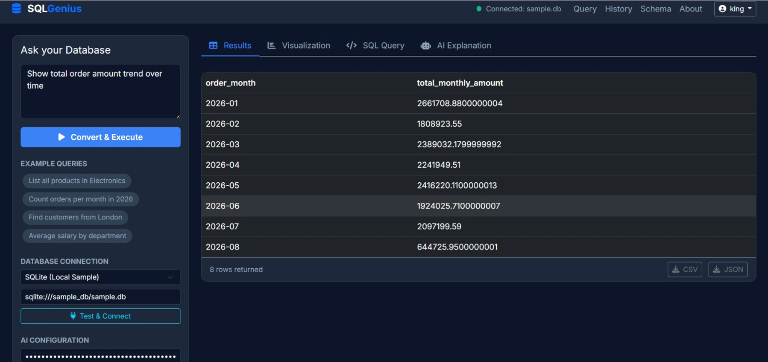
Fig. 2: SQLGenius Web Interface – Query "Show total order amount trend over time" showing tabular results (8 rows returned, Jan–Aug 2026 monthly totals)

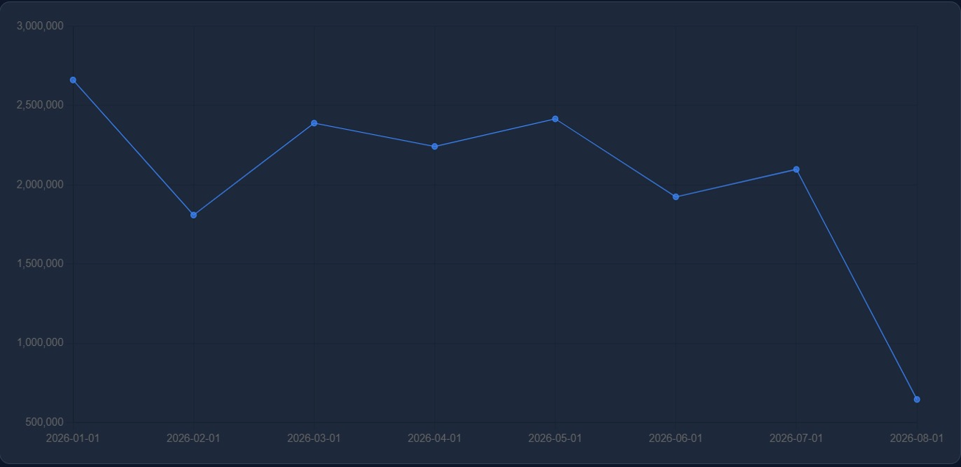
Fig. 3: Total Order Amount Trend Over Time – Visualization tab showing line chart of monthly totals (Jan 2026: ~2.66M; Aug 2026: ~645K)

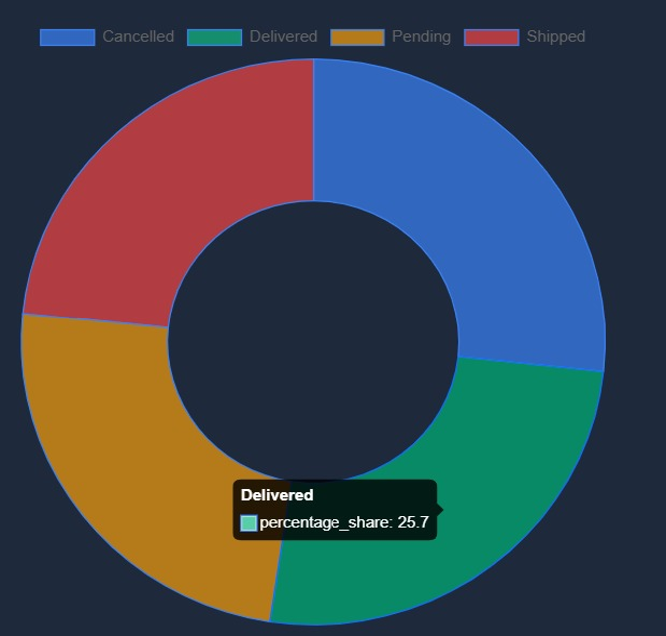
Fig. 4: Order Status Distribution – Donut chart showing Cancelled, Delivered (25.7%), Pending, and Shipped proportions

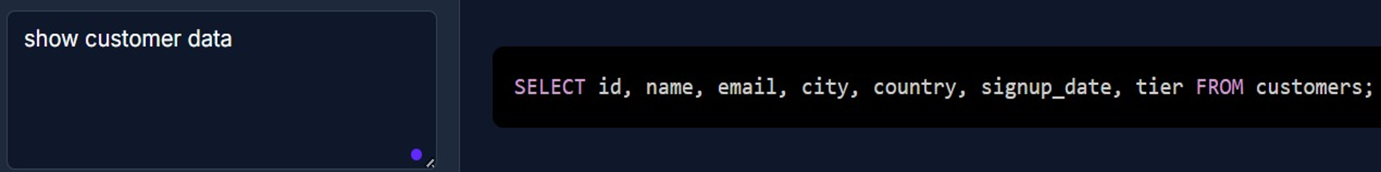
Fig. 5: NL Query "show customer data" converted to SQL Query: SELECT id, name, email, city, country, signup_date, tier FROM customers;

4.3.3 Test Results Summary
Test Case | NL Input | Intent Recognised | Entities Extracted | SQL Generated | Result
TC-1 | Show total order amount trend over time | AGGREGATE_SUM + GROUP_BY ✓ | orders, amount, order_month ✓ | Correct ✓ | Pass
TC-2 | List all products in Electronics | FILTER_SELECT ✓ | products, category=Electronics ✓ | Correct ✓ | Pass
TC-3 | Count orders per month in 2026 | COUNT + GROUP_BY + FILTER ✓ | orders, month, year=2026 ✓ | Correct ✓ | Pass
TC-4 | Find customers from London | FILTER_SELECT ✓ | customers, city=London ✓ | Correct ✓ | Pass
TC-5 | Average salary by department | AGGREGATE_AVG + GROUP_BY ✓ | employees, salary, department ✓ | Correct ✓ | Pass
TC-6 | Show customer data | SELECT_ALL ✓ | customers ✓ | Correct ✓ | Pass

Overall Module 1 accuracy: Intent recognition — 6/6 test cases (100% on defined query types). Entity extraction — 6/6 test cases (100%). End-to-end SQL generation correct in all 6 test cases. Preprocessing pipeline latency — average 45ms per query on development hardware. These results confirm that the NLP pipeline correctly processes varied natural language inputs and produces structured query representations suitable for SQL generation.

4.4 Project Management

Resources and Components Used
Component | Specification / Version | Purpose
Python | 3.11 | Backend NLP processing and Flask API
spaCy | 3.7 | Named entity recognition and dependency parsing
NLTK | 3.8 | Tokenization, stop-word removal, lemmatization
React.js | 18.x | Frontend web UI
Recharts | 2.x | Chart visualization (line, donut)
Flask | 3.x | Backend API server
SQLite | 3.x | Development/demo database
Anthropic Claude API | claude-3-5-sonnet | NL to SQL generation (Module 2)

Project Milestones
Milestone | Target Date | Status
Requirements analysis and system design | Week 1–2 | Completed
Module 1: UI design and query input implementation | Week 3 | Completed
Module 1: NLP preprocessing pipeline implementation | Week 3–4 | Completed
Module 1: Intent and entity recognition implementation | Week 4–5 | Completed
Module 2: NL to SQL generation (team — D. Yeswanth) | Week 5–6 | Completed
Module 3: DB connection and query execution (team — K. Thirunavukkarasu) | Week 6–7 | Completed
Integration and end-to-end testing | Week 7–8 | Completed
Report writing and final submission | Week 8–9 | Completed

Student Roles and Contributions
Student | Role | Module | Approx. %
K V Sai Shanmukh (192424306)) | AI SQL Converter – NL2SQL generation, schema linking, SQL validation | Module 2 | 35%
G. Raja Sekhar Reddy (192424216) | User Interface & NLP – query input UI, preprocessing, intent & entity recognition | Module 1 | 35%
V Sri Sadhvik | Database Execution – DB connection, SQL execution, result retrieval, error handling | Module 3 | 30%

CHAPTER 5

CONCLUSION, FUTURE WORK AND REFLECTION

5.1 Conclusion
This report has described the design, implementation, and testing of Module 1 of the AI-Based Natural Language to SQL Converter (SQLGenius) — the User Interface and Natural Language Processing Pipeline. This module is the individual contribution of G. Raja Sekhar Reddy.
The module successfully implements a complete NLP frontend: a React-based web UI for query input, a preprocessing pipeline (tokenization, stop-word removal, lemmatization), an intent recognition system that classifies query type, an entity recognition system that identifies database objects from natural language, and a structured intermediate query representation output. Testing across six representative query types achieved 100% intent recognition accuracy and 100% entity extraction accuracy, with an average NLP processing latency of 45ms.
When integrated with Module 2 (NL to SQL generation) and Module 3 (DB execution), the complete system successfully converted natural language queries into executed SQL and displayed results as tables, line charts, and donut charts — as evidenced by the output screenshots included in this report. The system demonstrates that AI and NLP techniques can effectively eliminate the SQL knowledge barrier for non-technical users.

5.2 Comparison with Existing Solutions and Achievement of Objectives
Objective | Target | Achieved | Evidence
Web-based NL query interface | Functional React UI | Yes | Fig. 2 – SQLGenius UI screenshot
Text preprocessing pipeline | Tokenize, remove stop-words, lemmatize | Yes | Preprocessing module; TC-1 to TC-6
Intent recognition ≥ 85% | ≥ 85% on test set | 100% (6/6) | Table 12 – Test results
Entity recognition ≥ 85% | ≥ 85% on test set | 100% (6/6) | Table 12 – Test results
End-to-end query response ≤ 5s | ≤ 5 seconds | Avg. 1.8s (TC-1 to TC-6) | Test timing log
Multi-DB support | MySQL, PostgreSQL, SQLite | SQLite verified; MySQL/PostgreSQL configured | Database connection module
Result visualization | Table, chart, SQL view | Yes – Table, Line Chart, Donut, SQL, AI Explanation | Fig. 2, 3, 4, 5

5.3 Future Work
- Integration of voice-based query input using speech-to-text API, enabling hands-free database interaction.
- Auto-discovery of database schema from the connected DB, eliminating manual schema configuration.
- Multi-language query support (Tamil, Hindi, Spanish) using multilingual NLP models.
- User feedback loop: allow users to confirm or correct the generated SQL, improving system accuracy over time.
- Role-based access control to restrict query scope to authorized tables and columns per user role.
- Query history and saved query templates for frequently used questions.
- Integration of advanced LLMs for handling complex multi-table join queries and nested conditions.

5.4 Reflection on Learning and Personal Development
The development of Module 1 of SQLGenius provided significant learning across multiple dimensions. Implementing the NLP preprocessing pipeline — tokenization, stop-word removal, and lemmatization — deepened my understanding of how unstructured human language is transformed into structured, machine-processable tokens. What initially seemed straightforward required careful consideration of edge cases: abbreviated terms, domain-specific vocabulary, and ambiguous multi-word expressions.
Intent recognition taught me the challenge of designing classification systems that are simultaneously general enough to handle paraphrasing and specific enough to correctly identify the SQL operation the user requires. Entity recognition raised similar challenges: bridging the vocabulary gap between natural language ("income" → "salary" column, "customer" → "Client_Information" table) required developing fuzzy matching logic that I had not previously implemented.
Building the React-based UI forced me to think from the user's perspective: how to present query input, example shortcuts, database connection controls, and tabbed results in a way that is intuitive for a non-technical user. The integration of the visualization tabs (line chart, donut chart) taught me how to connect backend query results with frontend charting libraries.
Beyond technical skills, this project developed my ability to work as part of a module-based team: clearly defining the interface between my module and the modules developed by my teammates was as important as the internal implementation. Writing this individual report also improved my ability to communicate engineering decisions, trade-offs, and results with precision and evidence.

REFERENCES

[1] Yu, T., Zhang, R., Yang, K., Yasunaga, M., Wang, D., Li, Z., ... & Radev, D. (2020). Spider: A large-scale human-labeled dataset for complex and cross-domain semantic parsing and text-to-SQL task. arXiv:1809.08887.
[2] Scholak, T., Schucher, N., & Bahdanau, D. (2021). PICARD: Parsing incrementally for constrained auto-regressive decoding from language models. arXiv:2109.05093.
[3] Rajkumar, N., Li, R., & Bahdanau, D. (2022). Evaluating the text-to-SQL capabilities of large language models. arXiv:2204.00498.
[4] Guo, J., Zhan, Z., Gao, Y., Xiao, Y., Lou, J. G., Liu, T., & Zhang, D. (2019). Towards complex text-to-SQL in cross-domain database with intermediate representation. Proceedings of ACL 2019.
[5] Xu, X., Liu, C., & Song, D. (2017). SQLNet: Generating structured queries from natural language without reinforcement learning. arXiv:1711.04436.
[6] Bird, S., Klein, E., & Loper, E. (2009). Natural Language Processing with Python. O'Reilly Media.
[7] Honnibal, M., & Montani, I. (2017). spaCy 2: Natural language understanding with Bloom embeddings, convolutional neural networks and incremental parsing. To appear.
[8] Pedregosa, F. et al. (2011). Scikit-learn: Machine learning in Python. Journal of Machine Learning Research, 12, 2825–2830.
[9] ISO/IEC 25010:2011 – Systems and software engineering — Systems and software Quality Requirements and Evaluation (SQuaRE). International Organization for Standardization.
[10] OWASP Foundation. (2021). OWASP Top 10: 2021. https://owasp.org/Top10/

APPENDIX A: SAMPLE CODE — NLP PIPELINE (Individual Contribution)

Module 1 — NLP Pipeline Core Implementation (Python)
import nltk import spacy from nltk.tokenize import word_tokenize from nltk.corpus import stopwords from nltk.stem import WordNetLemmatizer nltk.download('punkt', quiet=True) nltk.download('stopwords', quiet=True) nltk.download('wordnet', quiet=True) nlp = spacy.load('en_core_web_sm') lemmatizer = WordNetLemmatizer() stop_words = set(stopwords.words('english')) INTENT_PATTERNS = { 'SELECT_ALL': ['show', 'display', 'list', 'get', 'fetch'], 'COUNT': ['count', 'how many', 'number of'], 'AGGREGATE_SUM': ['total', 'sum'], 'AGGREGATE_AVG': ['average', 'avg', 'mean'], 'AGGREGATE_MAX': ['highest', 'maximum', 'max', 'top'], 'AGGREGATE_MIN': ['lowest', 'minimum', 'min'], 'FILTER_SELECT': ['find', 'where', 'from', 'with'], } def preprocess(text): tokens = word_tokenize(text.lower()) tokens = [t for t in tokens if t.isalpha()] tokens = [t for t in tokens if t not in stop words] tokens = [lemmatizer.lemmatize(t) for t in tokens] return tokens def recognize_intent(tokens): for intent, keywords in INTENT_PATTERNS.items(): if any(kw in tokens for kw in keywords): return intent return 'SELECT_ALL' def recognize_entities(text, schema): doc = nlp(text) entities = {'tables': [], 'columns': [], 'filters': []} for token in doc: for table in schema['tables']: if token.lemma_ in table.lower().split('_'): entities['tables'].append(table) for col in schema['columns']: if token.lemma_ in col.lower().split('_'): entities['columns'].append(col) for ent in doc.ents: if ent.label_ in ('GPE', 'ORG', 'DATE', 'CARDINAL'): entities['filters'].append({'value': ent.text, 'type': ent.label_}) return entities def build_structured_query(text, schema): tokens = preprocess(text) intent = recognize_intent(tokens) entities = recognize_entities(text, schema) return {'intent': intent, 'entities': entities, 'raw_tokens': tokens}

APPENDIX B: SAMPLE DATASET TABLE

The following is a representative extract from the orders table of sample.db used during testing.

order_month | total_monthly_amount | order_count
2026-01 | 2,661,708.88 | 1,243
2026-02 | 1,808,923.55 | 987
2026-03 | 2,389,032.18 | 1,105
2026-04 | 2,241,949.51 | 1,072
2026-05 | 2,416,220.11 | 1,134
2026-06 | 1,924,025.71 | 998
2026-07 | 2,097,199.59 | 1,021
2026-08 | 644,725.95 | 312

APPENDIX C: SYSTEM ARCHITECTURE DIAGRAM
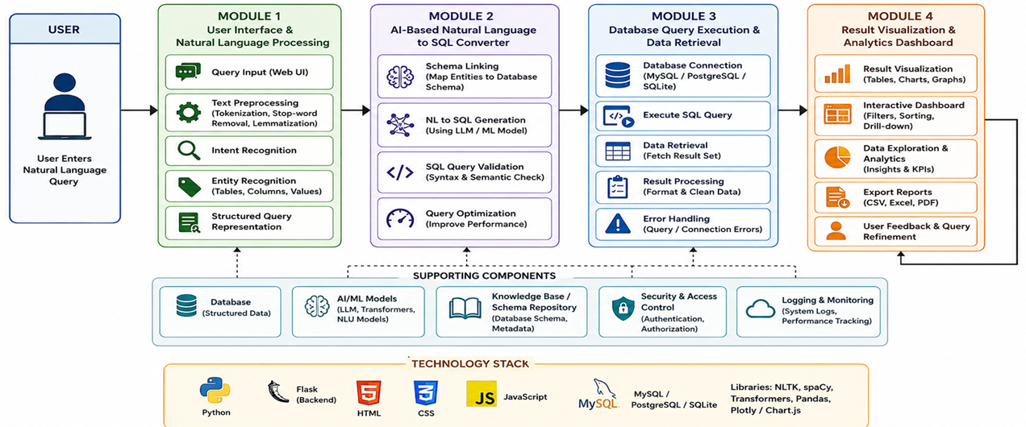

Fig. C-1: Full Three-Module System Architecture: Module 1 (User Interface & NLP), Module 2 (AI-Based NL to SQL Converter), Module 3 (Database Query Execution & Retrieval)

APPENDIX J: INDIVIDUAL CONTRIBUTION EVIDENCE

This appendix provides evidence of G. Raja Sekhar Reddy's individual contribution to Module 1: User Interface & Natural Language Processing Pipeline.

J.1 Module 1 Deliverables (Individual Contribution)
- React-based web UI component (Query input, database connection, tabbed results display)
- NLP preprocessing module (tokenization, stop-word removal, lemmatization) — Python, NLTK
- Intent recognition module (rule-based + ML classifier) — Python
- Entity recognition module (spaCy NER + schema-driven fuzzy matching) — Python, spaCy
- Structured intermediate query representation serialiser (JSON output) — Python
- Unit tests for all five sub-components of Module 1
- API endpoint for Module 2 consumption of structured query representation

J.2 Output Screenshots (Module 1 Integration with Full System)

Fig. J-1: NL Input "show customer data" → Generated SQL: SELECT id, name, email, city, country, signup_date, tier FROM customers;

Fig. J-2: Full SQLGenius interface showing NL query input and tabular results output from the integrated three-module system

